Prototype Build Plan
In the previous session, we created the storyboard. In this session, we are developing Prototype Version 1, which includes a welcome screen, lives system, score system, instructions, and game levels.
Hadshen and Vivek are responsible for different components of the prototype. Below, we have attached a screenshot of Prototype Version 1.
Figure 1 Prototype Version 1
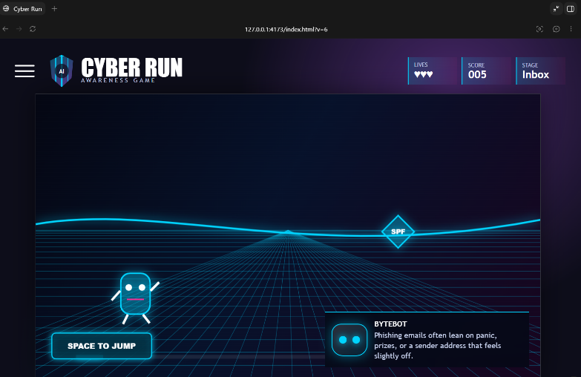
We are planning to develop our first screen with clearer instructions and additional design elements.

